
Company
Logotype

Cone Beam Computed Tomography- Report



Porur Dental X-rays & CBCT

Patient Name : Mrs. Porkodi Sripal | Date of Report : 17.04.2024
Age/ Gender : 39 years/ Male | Region of Interest : CBCT Mandible
Referring doctor: Dr. Subramoniam | Indication : Implant assessment
Clinical Notes: Nil
PATIENT INFORMATION

CBCT- Mandible provided
CBCT – IMAGE DETAILS

RADIOGRAPHIC INTERPRETATION

- Partially edentulous mandibular alveolar ridge (tooth present: 38)
- The mandibular alveolar ridge is present with normal trabecular pattern.

IMPLANT ASSESSMENT

 | 31 region | 32 region | 33 region | 34 region
Sub-Crestal (in mm)
Mid- Crestal (in mm)
Distance between alveolar ridge and the inferior border of mandible (in mm)
 | 35 region | 36 region | 37 region
Sub-Crestal (in mm)
Mid- Crestal (in mm)
Distance between alveolar ridge and the inferior alveolar nerve canal (in mm)
Distance between alveolar ridge and the inferior border of mandible (in mm)

RADIOGRAPHIC IMPRESSION

- Partially edentulous mandibular alveolar ridge.

Kindly correlate with clinical findings


IMAGES FOR REFERENCE

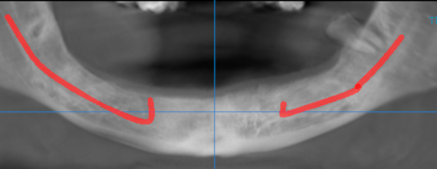

3-DIMENSIONAL VIEW

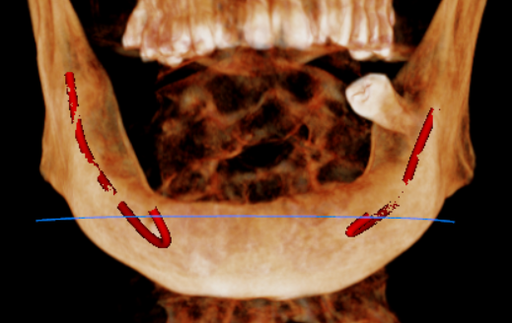

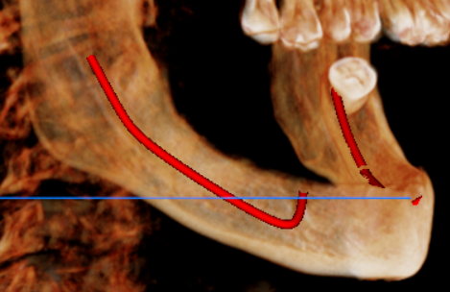
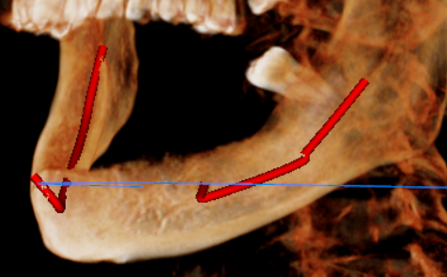

CROSS SECTIONAL VIEW

31 region | 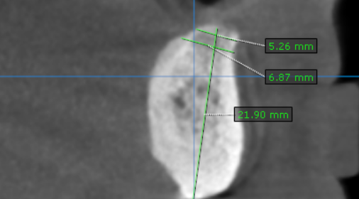
32 region | 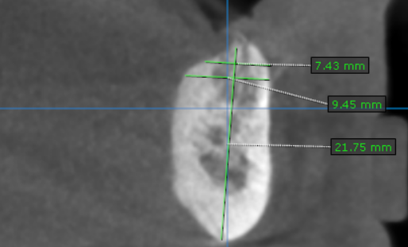
33 region | 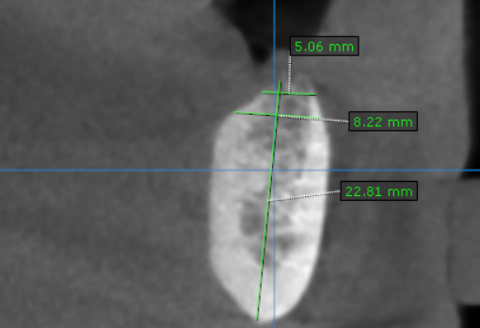
34 region | 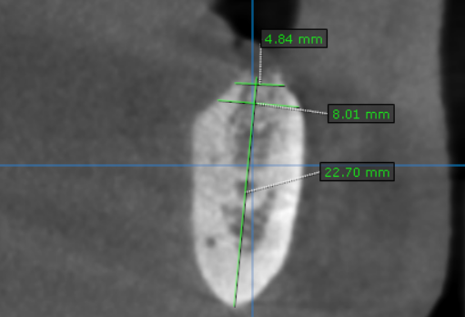
35 region | 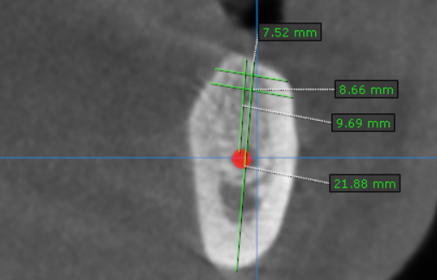
36 region | 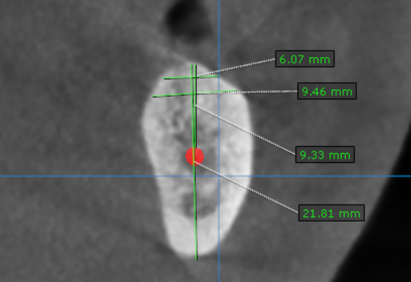
37 region | 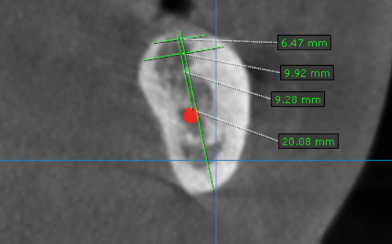
41 region | 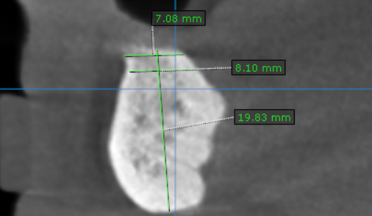
42 region | 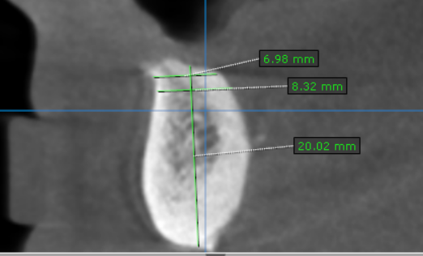
43 region | 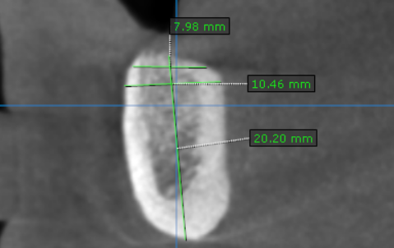
44 region | 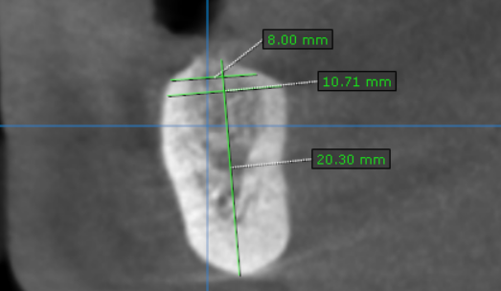
45 region | 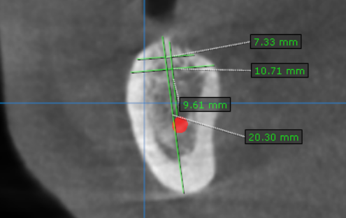
46 region | 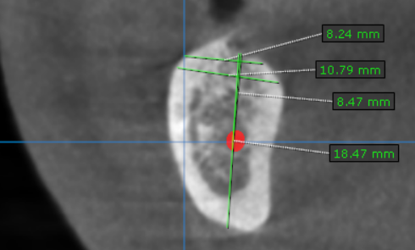
47 region | 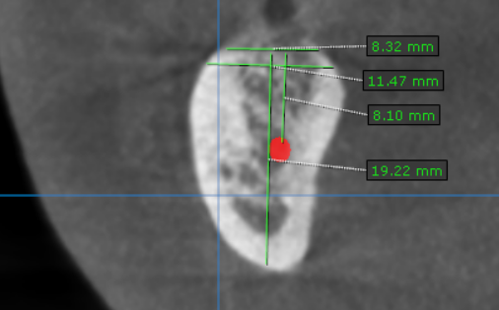

**** End of report ****

